**Feed back on the mentioned points previously 27/April/2025**

**Note: some points here are repeated as it reflect in different pages**

1. 49 needs clarification ( as admin ).
2. 40 needs clarification ( as admin ).
3. 18 there was an error. ( im still getting an error not sure why . if fixing this will take time , I can go live without it so im welling to drop it and focus on the other important points ) (DONE)
4. 41 contracts not reflecting correctly in English and Arabic for all users including our company ( admin ) side. (DONE) ( still contacts are not downloaded \ reflecting correct , in business owner account , photo is in both sides . in crowd account ,no id photo )   
   DONE ( Done )
5. 16 , it is still there for crowd account . (DONE) ) not in both accounts if I open notification it shows open , but the orange dot on the notification sign still there even if all is opened)   
   for example you have 10 notifications,  you clicked on notifications when you click on any notification, then it will mark as read, so for example you opened 8 notifications out of 10, still it will show yellow dot because, there 2 notifications unread, when you open all from 10, it will not show yellow dot. let me know if you have any suggestion on it or need more explanation. ( Done )
6. 20 , the photo point is solved , the rest still not. (DONE) Done
7. 23 it is done but it was not clear how to get there, maybe we can add a line under " "Ratings" so the user knows it is pressable. (DONE) Done
8. 29 needs clarification as it is still appearing b4 event. Is it for testing purposes? (DONE) ( as mentioned by your team , it is appearing now for testing purposes , so we can say Done ) DONE ( Done )
9. 32 it does show “applied " but still does not show " approved", even after payment .(DONE) (Done)
10. 36 old events still show “active”, you can even apply to it as a crowd .  
    (DONE) (Done)
11. 37 still the same. (Due to Timezone Settings When you change in admin it will be not reflect as a normal process. So, for event testing with date need to check from mobile app) (ok for now as a work around I subtract 3 hours to match it ,)
12. 38 I did receive some notifications but there are still missing notifications DONE ( Done )

Missing notification outside of the app , on the mobile notification screen :

1. you have an event today ( both crowds and business )
2. event has started ( both crowds and business )
3. event has ended ( both crowds and business)
4. you walked out of zone and now logged out . Need to scan code again .( for crowd and yes he has it inside the app but kindly let’s push it to mobile notification )
5. whatever notifications the user gets inside the app needs to be pushed to mobile notification. (Done) (kindly share vid) (Screenshot Shared.) ( Done but we need to correct some msgs has spelling mistakes . I will share via whatsup ) Done) (this time I went out of zone , waited for 5 minutes but no push notification when mobile is locked . once I opened the app the push notification and the inside app notification came up ) ( still not all in app notification are push notification outside of app , more accurately : the notification some time it comes some time it does not )(DONE :- Background and lock screen warning notification will come.)
6. 43 find the photo below pending : 1- There was no notification when the mobile is locked / I'm not opening the app , only when i opened / used the app the msg showed up. 2- note within the photo( we can use our already existing scan no need for new one) . 3- I checked the payment and I don’t think it deducted anything for logging out .

For point scan. Crowd can scan only 1 time for attendant event. (what if he walks out of zone ? the error say you have to punch in \ scan again to login ) If user come back to working zone, we are automatically detect, crowd dont need to rescan manual. ( ok )

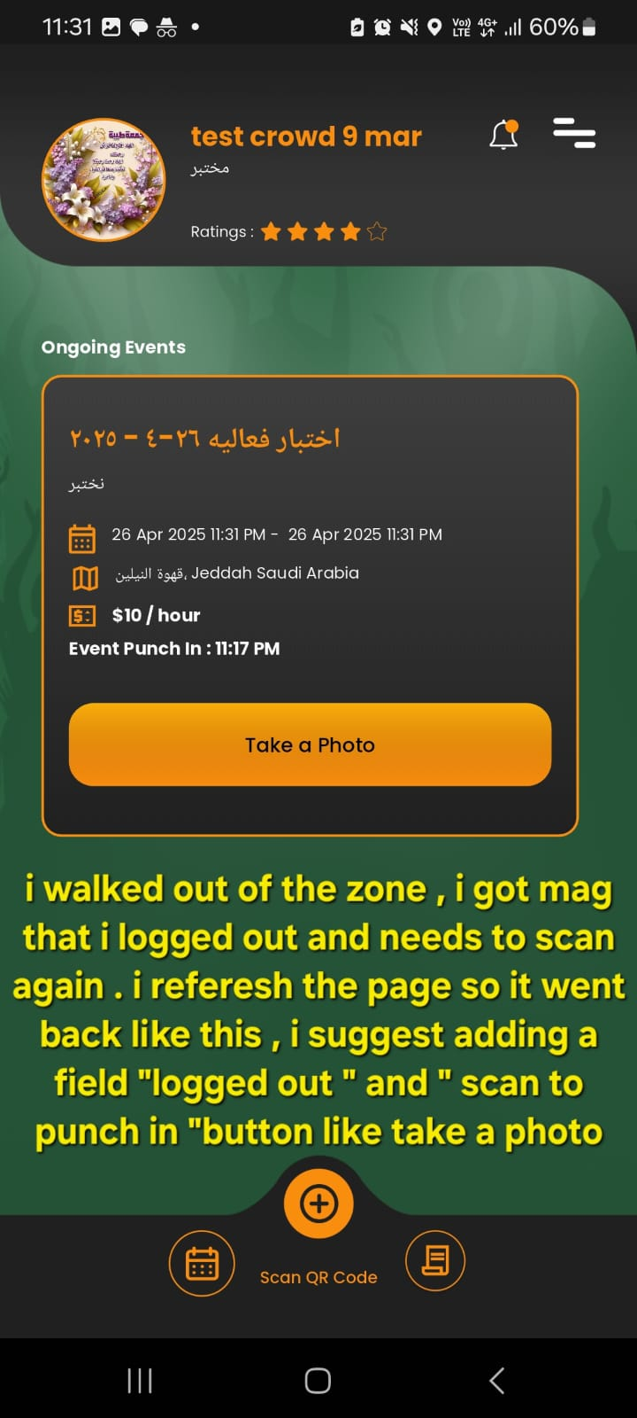

1. 40 we need to check this : what should show to me the admin and

what should show to business owner and what should show to crowd

***Admin*** : should be able to see and find all the details about the event and crowd and business , including the total payment from the business and how much each crowd made \ how much to deduct . so me the admin can pay each crowd accordingly .  
to check amount of crowd after event complete from admin, please check following url  
<http://188.166.84.211:8080/admin/resources/CrowdEventPayments> ( please share vid , I tried and it is not clear )

***Business owner*** : should be able to see and find the event info , how much he paid for this event ( total ***without*** details of how much each crowd made or deduction from crowd) , who attended the event who did not at all ( ***without*** details ) (Done)( please see comments : refer to photo below if business owner press details , it will show the details of payment for each crowd . this detailed info is only for admin and crowd account ) ( lets remove the details button for business ) (Done) (Done)  
  
***Crowds*** : what is in the photo above ( now that i added my comments with a photo , now this is talking about the photo above the above :P ) is perfect for the crowd. But there is a mistake in the calculation . (Need to talk with client) ( yes please let’s meet ) DONE ( Done but we need to meet for calculation ) OK.

1. 43 still : There was no notification when the mobile is locked / I'm not opening the app , only when i opened / used the app the msg showed up. (Done) ( this time I went out of zone and nothing happened at all , no msg no notification or push notification )  
   I've made some changes. Please check the new APK, and let me know if you encounter any issues. ( Done , the only thing is when the mobile is locked , the user does not know he went out . can we add vibration ? it is not important but it would be nice ) (Done) (vibration is added yes but no push notification : this time I went out of zone , waited for 5 minutes but no push notification when mobile is locked . once I opened the app the push notification and the inside app notification came up )  
   I've made some changes. Please check the new APK, and let me know if you encounter any issues.
2. 46 notification should be sent to and crowds business owner that event has ended ( ps : yes business owner received an invoice generated msg but that is wrong , his invoice was generated when he paid, but this notification will be good if we send it to the crowd just replace the word invoice by service fee ) (DONE) ( Done )
3. 47 it should show the business only his invoice ( include only the same details when he did payment , like number of crowds total payment and event info ) ( no details of each crowd how much he made \ deduction amount ) (Need to talk with client) ( yes please let’s meet )  
   (DONE :- We have removed the details button)
4. 49 this is the point where i as an admin need to check to know how much to pay eachcrowd **. (Admin Panel Changes)** ( needs clarification video or document ) (Will explain you in meeting)
5. **.**
6. Also there was no notification on the mobile that i logged out / walked out of event zone . I checked payment , I don’t think it deducted when I was logged out and maybe did not log me out . (Backend – side check)(Need to talk with client) ( this time I went out of zone and nothing happened at all , no msg no notification or push notification . yes please let’s meet )   
   I've made some changes. Please check the new APK, and let me know if you encounter any issues. ( Done ) ( note : I did not attend an event I was approved and it is paid , I received warning msgs but did not get a kicked out msg )   
   ANS :-  
   I created an event and check with two users — one attended and the other did not. The attendee received the payment, while there’s no payment entry for the user who didn’t attend. This part is working as expected. Also for warning Currently, the system checks every five minutes if the user is within the event area. If they are inside, tracking continues. If they are outside, a warning is sent. After five warnings, the user receives a kick-out message and is removed from the event. This flow is implemented and functioning correctly. If you need any changes, please let us know.( I can’t find the events I created and paid after approving a corwd , crowd did not attend . the event is no where to be found )  
   I've made some changes. Please check the new APK, and let me know if you encounter any issues.
7. Would you kindly check from business account , in the event you created , did the system count the crowd who did not attend as absent ? As last time it shows 0 absents . 2- also , I did mention above in L 43 what happened this time when I went out of zone 3- I shared via whats up , I cant find and event as a business owner to check the count of absents and the total payment )  
   I've made some changes. Please check the new APK, and let me know if you encounter any issues.
8. Follow up for/ completing 43. ( this time I went out of zone and nothing happened at all , no msg no notification or push notification . yes please let’s meet )   
   I've made some changes. Please check the new APK, and let me know if you encounter any issues. ( Done ) ( note : I did not attend an event I was approved and it is paid , I received warning msgs but did not get a kicked out msg )  
   ANS :-  
   I created an event and check with two users — one attended and the other did not. The attendee received the payment, while there’s no payment entry for the user who didn’t attend. This part is working as expected. Also for warning Currently, the system checks every five minutes if the user is within the event area. If they are inside, tracking continues. If they are outside, a warning is sent. After five warnings, the user receives a kick-out message and is removed from the event. This flow is implemented and functioning correctly. If you need any changes, please let us know.
10. --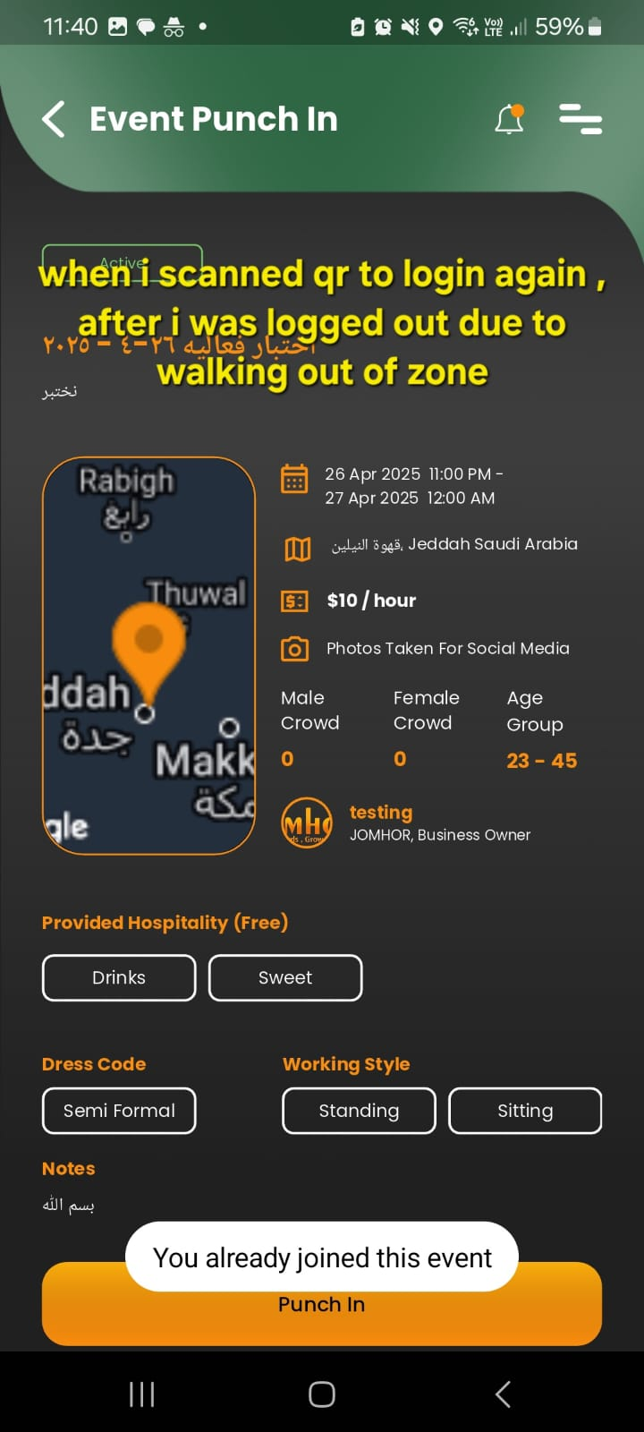 The 'Scan Again' message has been updated. The location tracker now automatically detects when a user is inside the event, eliminating the need for repeated scans. Additionally, if a user is removed from the event, a kickout message is displayed along with the reason on the Dashboard.

Maybe it did not log me out ( I did not attend an event I was approved and it is paid , I received warning msgs but did not get a kicked out msg )  
  
ANS :-  
I created an event and check with two users — one attended and the other did not. The attendee received the payment, while there’s no payment entry for the user who didn’t attend. This part is working as expected. Also for warning Currently, the system checks every five minutes if the user is within the event area. If they are inside, tracking continues. If they are outside, a warning is sent. After five warnings, the user receives a kick-out message and is removed from the event. This flow is implemented and functioning correctly. If you need any changes, please let us know.

1. A screenshot of a black and orange screen

   AI-generated content may be incorrect.
2. We need to talk about " your invoice is generated " and this page showing for business owner ( repeated point , I already wrote the notes up in point N )(Need to talk with client) (yes please let’s meet)

The payment details have already been set for everyone. If you’d like to make any changes, we can discuss them during the meeting. (yes please let’s meet to address the calculation and the payment details for business ) OK.

1. --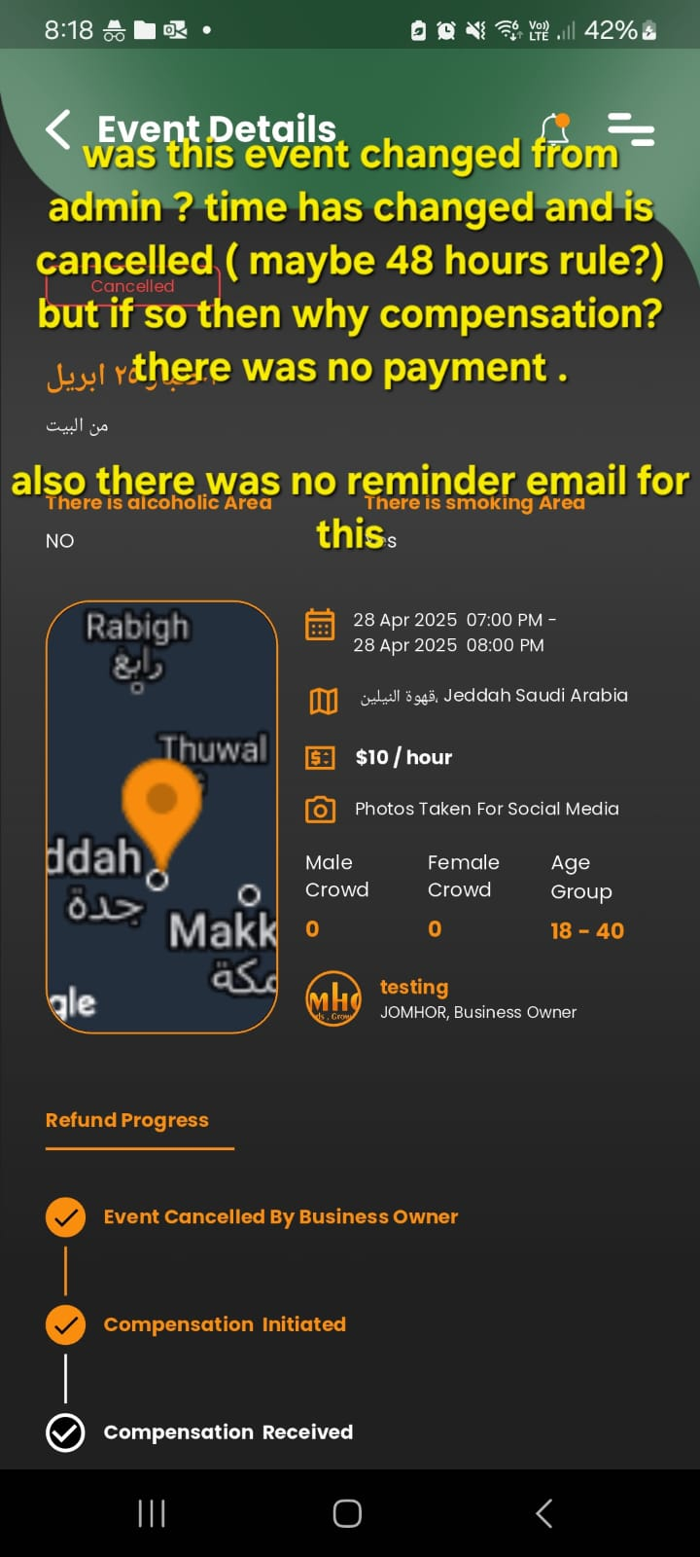(Not getting anything which describe that compensation is need) ( let’s check why or how this was cancelled , so after it can be clear if compensation is needed or not . note ,as agreed b4 if there was no payment before 48 hour of the event , the event should cancel automatically )   
   The cancellation process is defined based on the cancellation status. ( kindly I mean can we check in the system\ history how this got cancelled ? I have a new event to check as well ) (will discuss in meeting)
2. ---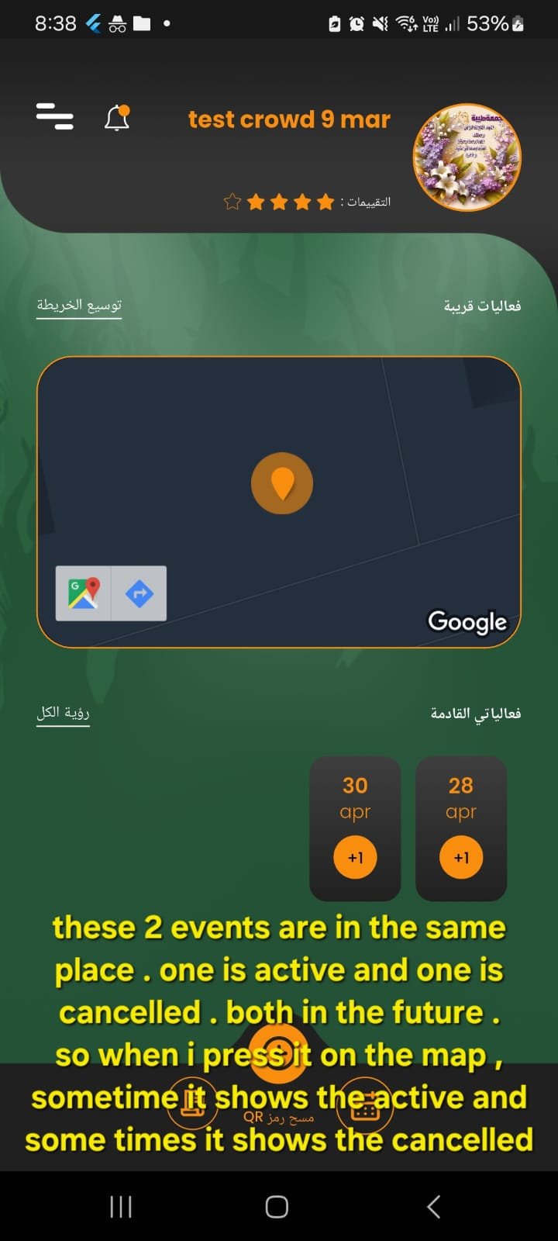Screens screenshot of a phone

   AI-generated content may be incorrect.(There are multiple events available. When the user clicks for the first time, the first event in the list is displayed. On the second click, the next event is shown, and so on—each click cycles through a different event. Additionally, a zoom functionality has been implemented to allow users to focus on a particular event in detail; by zooming in on the event, the user can view it individually. However, since the first event happens to be a cancelled event and the second one is an active event, this is why both types (cancelled and active) are being shown in sequence)  
     
    ( ok what is the suggested solution for that ?)

"The current functionality is designed to provide a seamless browsing experience through multiple events, regardless of their status (active or cancelled). When the user clicks, it cycles through all available events in order, giving a complete overview.

The zoom feature further enhances this by allowing users to focus on any particular event individually. Since events are listed as per the order received from the backend, both active and cancelled events appear as part of the sequence.

This approach ensures transparency and consistency in how events are presented to the user." ( ok )

1. 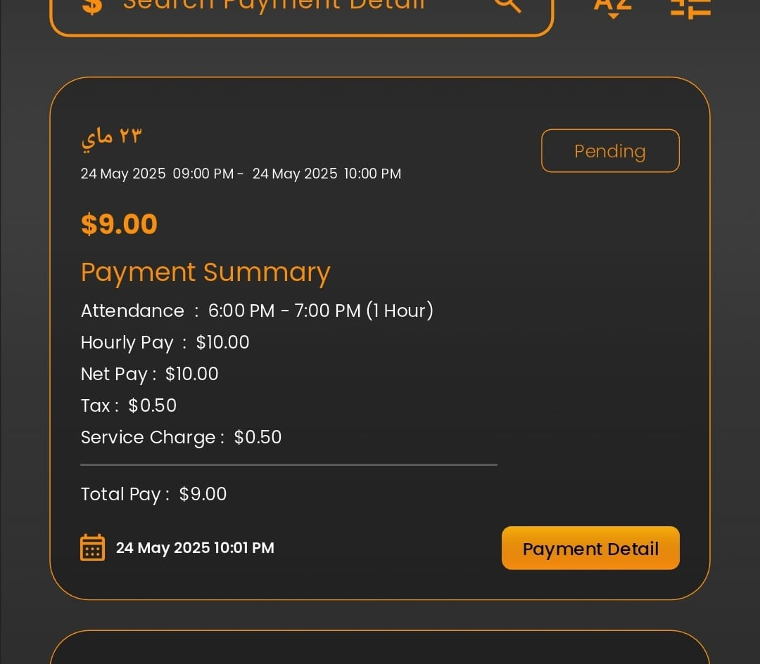

Thank you for adding this to crowd account , but I went out of zone , no deduction . And why is it deducting tax and service ?

The tax and service deductions are currently set according to the existing configuration. If you would like any changes, please let us know your preferred approach—specifically how you’d like the deductions to be calculated and displayed. Your input will help us make the necessary adjustments.( yes please let’s meet and I have the equations ready for that as well , I will reshare them if needed but meeting will help ) OK.